Parameter search for NNF & PNF 1M8

For SNF 1M8

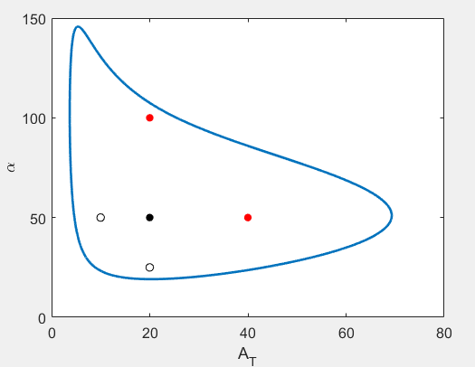

Parameter values are

Kd=1, Vmax=5, Km=5.5, KA=20, AT=20, alpha=50;

When additional auxiliary loops are added, few constraints needs to be met

1. Average AT close to AT in SNF;

2. Relative amplitude of AT ~20%;

3. Constraints for KV and KR as stated in the non-dimensionalization document.

Taken together, we need to find $δ$, $A_{MAX}$ and $V_{MAX}$ such that $\max_{t}{V(t)}<10$ and the average of $A_{\text{T}}(t)$ matches $A_{\text{T}}$ in the corresponding SNF model.

Taken together, we need to find $δ$, $A_{MAX}$ and $R_{MAX}$ such that $\max_{t}{R(t)}<5$ and the average of $A_{\text{T}}(t)$ matches $A_{\text{T}}$ in the corresponding SNF model.

Parameter search for NNF 1M8

lb = [1e-2 1e-2 1e-2]

ub = [1e2 1e2 1e2]

δ = 0.17, $A_{MAX}=41$, $V_{MAX}=14$

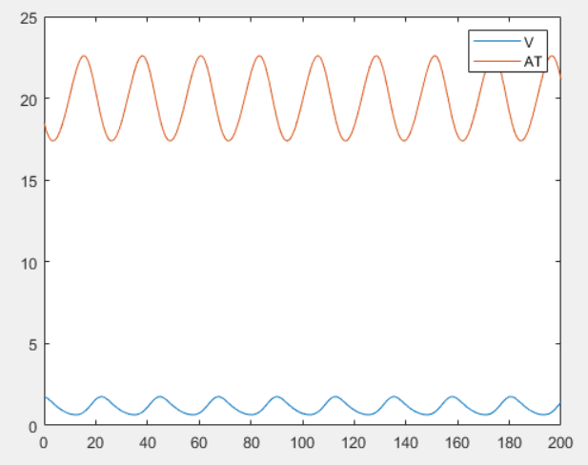

average(AT) ~ 20 which is similar to At0=20 in SNF 1M8

relative amp is ~ 0.25

max(V) ~ 2

PNF 1M8

δ = 0.12, $A_{MAX}=56$, $R_{MAX}=6.5$

